Martha Guzman
Assignment 1.2
6/7/2026

Link to GitHub repository: https://github.com/Martha-Codes/csd-310.git

Screenshot of GitHub Repository

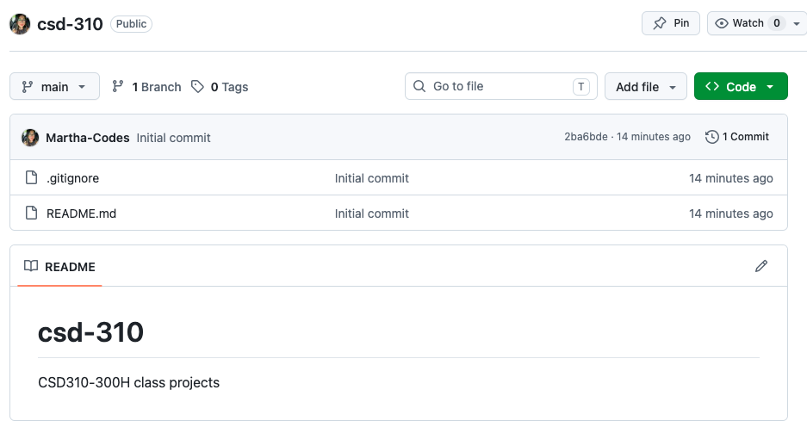

Screenshot of Local Directory:
